**SOUTHERN RIVER COLLEGE**

**Human Biological Science**

**Unit 3 & 4**

**TASK 11 – Test 5**

**Hominid Evolutionary Trends**

**MARKING KEY**

**Time: 60 mins**

Multiple Choice: 12 marks

Short Answer: 34 marks

Extended Answer: 12 marks

TOTAL 58 MARKS

**Weighting: 5%**

**Do not write on this question booklet**

**Do not turn page until instructed to do so**

**Section A: Multiple Choice (10 Marks)**

Answer all questions by placing an X through the most correct answer on the multiple choice answer sheet.

Questions 1 & 2 refer to the lower jaw diagrams shown below.



Jaw R

Jaw Q

Jaw P

1. Which of the following statements about the lower jaws shown in the diagrams is correct?
2. Jaw P belongs to a modern human because the dental arcade has a parabolic shape.
3. Jaw Q belongs to a pongid because the teeth are of an even size.
4. Jaw P belongs to a pongid because of the presence of a diastema.
5. Jaw Q belongs to a modern human because there are more molars present than  in Jaw P.
6. If the complete skeleton of the specimen belonging to Jaw R was examined, which of the following characteristics would it be expected to have?
7. longitudinal and transverse arches of the foot
8. small outer condyle of the femur at the knee joint
9. only one curvature of the vertebral column
10. bowl shaped pelvis that is long from top to bottom
11. Which of the following correctly matches the hominid to the associated lifestyle change?
12. Homo habilis – food sharing, Homo erectus – cave murals
13. Homo habilis – use of fire, Homo sapiens – cooperative hunting
14. Homo neanderthalensis – development of agriculture, Australopithecines – home bases
15. Homo habilis – food sharing, Homo erectus – cooperative hunting
16. Compared to Homo erectus, the Neanderthals had a:
17. prominent brow ridge.
18. prognathic face.
19. larger brain size.
20. shorter sagittal crest.
21. With which of the hominids is the use and control of fire associated?
22. Homo sapiens
23. Homo habilis
24. Homo neanderthalensis
25. Homo erectus
26. A fossilised skeleton was discovered in a semi-arboreal region of Africa. Paleoanthropologists determined that the skeleton is bipedal due to several distinguishing features. What features would you expect to be present in this skeleton?

1. narrow pelvis, s-shaped spine, protruding jaw
2. central foramen magnum, protruding jaw, short pelvis
3. s-shaped spine, long pelvis, central foramen magnum
4. broad pelvis, central foramen magnum, s-shaped spine
5. The following list refers to hominid physical characteristics:
6. Small brain size relative to body size.
7. Dental diastema.
8. Centrally placed foramen magnum.
9. S-Shaped vertebrae curve.
10. Transverse arch in the foot.
11. Prominent brow ridges

Which characteristics would you expect to find in a fossilised pongid (ape)?

1. 1, 2 and 6
2. 1, 5 and 6
3. 2, 4 and 6
4. 1, 4 and 6

Questions 8 and 9 refer to the diagram below of hominid lower limbs.

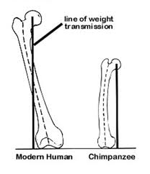

1. The femur of hominid A has a greater carrying angle than hominid B. This is because hominid A is
   1. human and the carrying angle allows it to have a wider pelvis than an ape, to assist in childbirth.
   2. an ape and the carrying angle increases the length of the femur to allow for quadrupedal walking.
   3. an ape and the carrying angle allows the knee to bend and straighten for bipedal walking.
   4. human and the carrying angle places the foot under the centre of gravity for a striding gait.
2. The foot of hominid A would have
   1. a larger calcaneus (heel bone) than Primate B.
   2. a longitudinal arch that is lacking in Primate B.
   3. greater opposability of the big toe than Primate B.
   4. a more flexible ankle joint than Primate B.

Questions 10 and 11 refers to the diagram below.

COMMON PYGMY

GIBBON ORANGUTAN GORILLA CHIMP CHIMP HUMAN

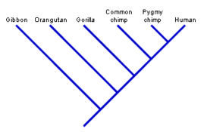

1. Using the data in the phylogenetic tree pictured above, which two (2) organisms are the most closely related?
2. Pygmy chimp and human
3. Common chimp and human
4. Orangutan and common chimp
5. Human and gibbon
6. Which two (2) organisms are the most distantly related?
7. Pygmy chimp and human
8. Common chimp and human
9. Orangutan and common chimp
10. Pigmy chimp and gibbon
11. Humans have opposable thumbs. Opposable thumbs allow humans to:
12. grasp objects.
13. write with a pen.
14. touch the wrist of the same hand.
15. touch the tip of fingers with the thumb on same hand.

**End of Section A**

Name _________________________________________

Teacher_________________________________________

**SOUTHERN RIVER COLLEGE**

**Human Biological Science Unit 3 & 4**

**TASK 12 – Test 5 - Hominid Evolutionary Trends**

TOTAL / 60 MARKS

**Multiple choice & answer booklet**

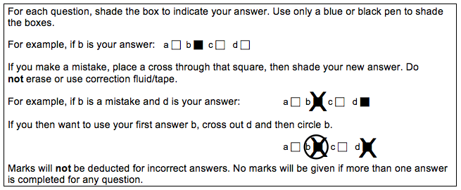

|  |  |
| --- | --- |
| **11** | a ⬜ b ⬜ c ⬜ d ⬜ |
| **12** | a ⬜ b ⬜ c ⬜ d ⬜ |
|  | a ⬜ b ⬜ c ⬜ d ⬜ |
|  | a ⬜ b ⬜ c ⬜ d ⬜ |
|  | a ⬜ b ⬜ c ⬜ d ⬜ |

|  |  |
| --- | --- |
| **6** | a ⬜ b ⬜ c ⬜ d ⬜ |
| **7** | a ⬜ b ⬜ c ⬜ d ⬜ |
| **8** | a ⬜ b ⬜ c ⬜ d ⬜ |
| **9** | a ⬜ b ⬜ c ⬜ d ⬜ |
| **10** | a ⬜ b ⬜ c ⬜ d ⬜ |

|  |  |
| --- | --- |
| **1** | a ⬜ b ⬜ c ⬜ d ⬜ |
| **2** | a ⬜ b ⬜ c ⬜ d ⬜ |
| **3** | a ⬜ b ⬜ c ⬜ d ⬜ |
| **4** | a ⬜ b ⬜ c ⬜ d ⬜ |
| **5** | a ⬜ b ⬜ c ⬜ d ⬜ |

**Section B: Short Answer (35 Marks)**

Answer all questions in the spaces provided.

**Question 13 (4 marks)**

Part (a) of the question refers to the diagram of a primate phylogeny below.

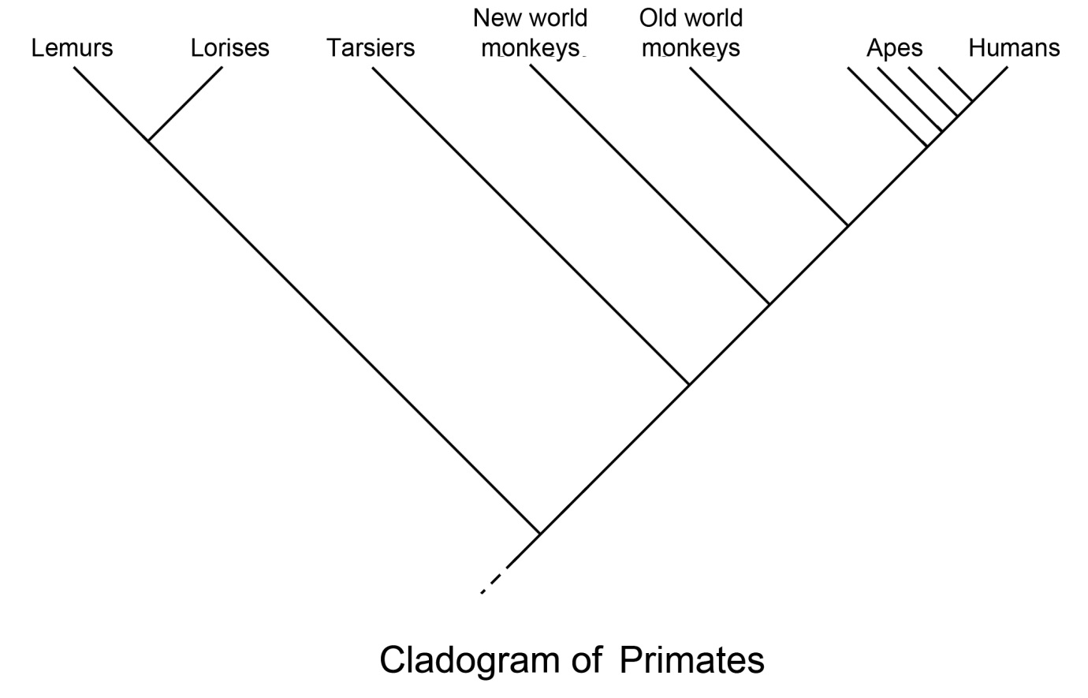

1. According to the phylogeny, which group of primates was the first to diverge in evolutionary time? (1 mark)

Lemurs and lorises (must say both, no half marks).

1. Complete the table below, describing the evolutionary trends that occur within Hominids.

(3 marks)

|  |  |
| --- | --- |
| **Characteristic** | **Evolutionary trend** |
| Mobility of digits of the hand | Any of the following for 1 mark   * Increased opposability of the first digit/thumb * Increased dexterity/ mobility * Increased ability to move digits independently of each other * Better precision grip |
| Dental arcade | * Change from U shape to parabolic shape (1)   (must include comparison of U shape to parabolic) |
| Diastema | * Present in apes and early australopithecines, absent in later species (1) (MUST include comparison of early hominids to later species) |

**Question 14 (10 marks)**

Part (a) & (b) of the question refers to the diagram of the Hominid specimenskull below.

1. Name the Hominid specimen below. (1 mark)

Australopithetcus afarensis (must say all)

1. For each of the parts identified in the diagram of the skull, describe how the skull of *Homo habilis* differs from that shown in the diagram and give **one** advantage for *Homo habilis* for each change. (6 marks)

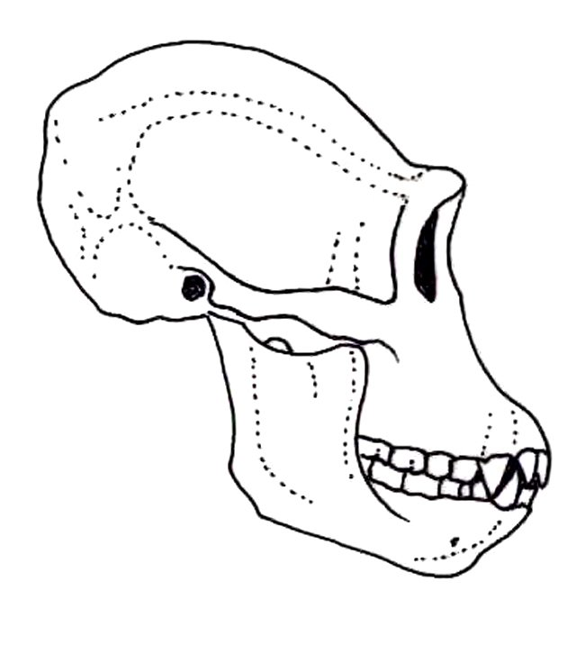

**Z**

**X**

**Y**

|  |  |  |
| --- | --- | --- |
|  | **How the skull of a typical modern *Homo erectus* differs to the diagram** | **Advantage** |
| **X** | Any 1:   * Less pronounced brow ridges * presence of forehead/ smaller muscle groups | Any 1:   * Eyes protected by heavy orbital ridge * Allows for increased cranial capacity/frontal lobe * Less energy required for muscle development and maintenance |
| **Y** | Any 1:   * Smaller teeth * Smaller canines * No diastema | Any 1:   * Change in diet /greater variety of foods * Skull is better balanced for bipedalism |
| **Z** | Any 1:   * Temporal lobe filling/widening | Any 1:   * Allows for increased cranial capacity/temporal lobe |

**Question 15 (6 marks)**

Part (a) of the question refers to the tool diagrams A, B, C and D shown below.

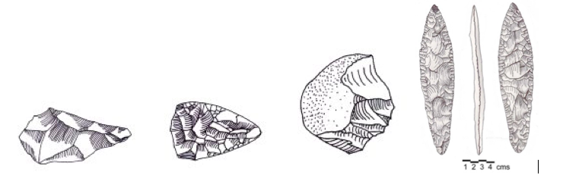 **A B C D**

1. Complete the table below by placing the tools A, B, C and D in the correct evolutionary sequence. Include the hominin species it is associated with.

(5 marks)

1 mark ONLY if letter matches hominid, no half marks

|  |  |  |
| --- | --- | --- |
|  | **Letter – A, B, C or D**  **1 mark correct order** | **Used by** |
| **Oldest**  **Youngest** | **C** | **Homo habilis** |
| **A** | **Homo erectus** |
| **B** | **Homo neanderthalensis** |
| **D** | **Homo sapiens** |

1. Hominin tool culture has distinctly changed over time. Describe **one** trend relating to manufacture. (1 mark)

|  |  |
| --- | --- |
| **Describe** | **Mark** |
| Increased workmanship | Any 1 |
| Increased number of flakes |
| Finer detail |
| More complex designs |
| Increased variety of materials used |
| Become more specialized for specific functions |

**Question 16 (4 marks)**

The table below give information on cranial capacity, height and mass of our early human ancestors up to modern day humans. (*All data is approximate*)

|  |  |  |  |
| --- | --- | --- | --- |
| **Species** | **Cranial capacity (cm3)** | **Height (m)** | **Mass (kg)** |
| *Australopithicus afarensis* | 430 | 1.2 | 30 |
| *Australopithicus africanus* | 460 | 1.3 | 35 |
| *Paranthropus robustus* | 540 | 1.5 | 65 |
| *Homo habilis* | 600 | 1.3 | 45 |
| *Homo erectus* | 1050 | 1.7 | 60 |
| *Homo neanderthalensis* | 1485 | 1.6 | 70 |
| *Homo sapiens* | 1350 | 1.9 | 75 |

(a) What conclusion can be drawn from the data given on cranial capacity? (2 marks)

|  |  |
| --- | --- |
| **Conclusion** | **Marks** |
| Cranial capacity has (generally) increased over time | 1 |
| Due to increased size of brain | 1 |
| **Total** | 2 |

(b) Using only the height and mass data of *Homo neanderthalensis* and *Homo sapiens,* give a possible explanation for this difference in build. (2 marks)

|  |  |
| --- | --- |
| **Explanation** | **Marks** |
| *Homo neanderthalensis* lived in Europe whereas *Homo sapiens* from Africa | Any 2 |
| Colder climate in Europe |
| *Homo neanderthalensis* shorter and stockier than *Homo sapiens* |
| Reduced surface area to lose less heat |
| **Total** | 2 |

**Question 17 (13 marks)**

Archaeologists are studying evidence collected from a fossil dig. They believe the fossil remains belong to *Homo neanderthalensis* and have dated the age of the site at approximately 100, 000 years. The archaeologists are searching for more evidence to support their theory.

1. Identify **two** pieces of evidence, **not** including the skeletal remains, that archaeologists might find at the site. For each, propose the cultural behaviour associated with *Homo neanderthalensis* that the evidence suggests.

(4 marks)

Any 2 evidence (2) plus linked behaviour (2)

|  |  |
| --- | --- |
| **Archaeological evidence** | **Cultural behaviour** |
| Tool artefacts/ remains of tool manufacture | Use of smaller blades, finely hade/ Mousterian tools/ bone fish hooks/ flaked tools/needles |
| Butchery sites/ hunting tools/ piles of animal bones | Large hunting groups/ cooperative hunting/ diet including meat |
| Plant remains/ seeds in human remains/ seeds in kitchen middens | Cooperative gathering/ omnivorous diet/sharing food and resources |
| Burnt bone or wood in hearths/ torches | Use of fire/cooking/warmth/light/protection |
| Burial sites | Sign of ceremonial burials |
| Cave painting | Earliest signs of art |
| Flute/early instruments | Earliest signs of music |

1. Suggest **two** possible explanations for the extinction of *Homo neanderthalensis*.

(2 marks)

|  |  |
| --- | --- |
| **Explanation** | **Marks** |
| Natural selection | Any 2 |
| *Homo sapiens* larger frontal lobe |
| *Homo sapiens* more intelligent |
| Competition for resources |
| Introduction of agriculture in Homo Sapiens (more efficient at producing food) |
| Fighting between Homo sapiens and Homo neanderthals |  |
| **(Accept reasonable explanation for Homo sapiens outcompeting Homo neanderthalensis) Total** | 2 |

1. Explain THREE possible reasons why humans changed from a hunter-gatherer lifestyle to an agricultural one.

(3 marks)

|  |  |
| --- | --- |
| **Explain** | **Marks** |
| Better understanding of seasons | Any 3 |
| More fertile soils in one location |
| Desire for more permanent towns and villages. |
| Reduction in big game animals for hunting |
| Warm climate with adequate rainfall for growing crops/increase water supplies |
| Availability of reliable food sources |
| Availability of animals that could be domesticated |
| Grains suitable for hybridisation |
| Larger populations need more food |
| Safer method away from predators |
| Greater range of food was made available, veg, meats etc |
|  |

A footprint was found at an alternative site and on the basis of tools also found there, the archaeologists concluded the footprint belonged to early *Homo sapiens*.

1. Identify **two** types of tools that could provide support for the fossilised footprint to belong to Homo sapiens. For each type identify one feature of these tools.

(4 marks)

Any **2** tools and **one** associated feature for each (1 mark per box)

|  |  |
| --- | --- |
| **Tool Type** | **One feature of this type of tool** |
| Aurignacian Tools | * Blade tools |
| Solutrean Tools | * Willow-leaf * Laurel-leaf blades * Bifacial points   Do not accept: “leaf-like” or “two points” must include terminology above |
| Magdalenian Tools | * Geometrically shaped * Triangles and semilunar shapes * Bones used to make wedges/hammers/spearheads * Single tools made from multi materials (bone, ivery and antler combined) |

**End of Section B**

**Section C: Extended Answer (12 Marks)**

Answer the question below in the space provided

**Question 18**

When first discovered, scientists believed that the Australopithecines were bipedal and walked with a striding gait.

a) Explain two selection pressures (advantages) that may have led to the development of bipedalism in early hominids. (4 marks)

1 mark for selection pressure/advantage and 1 mark for explanation

Accept only first two answers

|  |  |
| --- | --- |
| **Selection Pressure/advantage** | **Explanation** |
| Reduction in forest / changing to open savannah grasslands | Need to be upright to see predators |
| Better visibility | Able to detect predators |
| Increase in apparent size | Might deter predators |
| Increases height/limited food resources | Can reach food on higher branches |
| Leaves hands free | To carry food/to make tools/carry weapons/carry children. |
| Allows striding gait | More energy-efficient way of walking |
| Decreased SA exposed to sun | Improved cooling/reduce heat gain |

b) Describe four pieces of fossil evidence from the knee upwards that supports this belief and for each, explain the advantage to bipedalism that it provides. (8 marks)

1 mark for fossil evidence/feature and 1 mark for corresponding advantage.

Accept first 4 answers

|  |  |
| --- | --- |
| **Evidence/feature** | **Advantage** |
| Foramen magnum positioned underneath skull | skull better balanced for bipedalism |
| Reduced prognathism | brings centre of balance over feet |
| Wedge shaped lumbar vertebrae  S-shaped curve to vertebral column | Straightens spine/ support the weight of the body  Enables head to be balance on top of vertebral column/brings centre of gravity over the feet |
| Deep acetabulum/hip socket | facilitates carrying angle |
| Pelivis is bowl shaped/ broad and short  pelvis | gives support to abdominal organs/ large surface for attachment of muscles |
| Iliac crest (side of pelvis) more rounded/larger muscle attachment | Gluteal medius attached on side to stabilize hip whilst striding |
| Femur is angled inwards/ carrying angle. | This allows for the positioning of the body’s weight to transfer to the outer portion (condyle) of the knee when one leg is moving (off the ground)/lower center of gravity between feet |
| Length of femur | to increase stride/gait/more energy efficient travel more energy efficient travel/ lowers center of gravity |
| Outer/lateral condyle  OR  Medial condyle enlarged | more robust for load bearing  to compensate for carrying angle and  facilitate articulation with tibia |

Can accept: Decrease in size of nuchal crest (1)

* + - Advantage: save energy in producing/use of these muscles (1)

No other real advantage in terms of bipedalism.

DO not accept: arms shorter than legs as this doesn’t relate to austalopithecines

Answer excludes the foot.

**Question A OLD**

A series of adaptations that provided for erect stance are considered to be an essential component for later cultural evolution in early human ancestors. The Australopithecines are considered to be the first hominids to display these adaptations to erect posture.

Consider the lower limb, including the pelvis. Describe **four** adaptations to erect posture that are exhibited by the Australopithecines and early Homo and discuss the advantage they provide. Discuss their impact on subsequent cultural evolution in the early human ancestors.

**Any four pairs for a maximum of 8 marks**

|  |  |
| --- | --- |
| **Describe: Adaption** | **Discuss: Advantage** |
| Short, wide pelvis | To support abdominal organs/ support a carrying angle at the knees/muscle attachment for gluteals |
| Pelvis tilts forward | to help create lumbar curve |
| Carrying angle of knees | so they sit directly under midline of the body |
| Long femurs | allow an energy efficient long stride length/lower centre of gravity |
| Large medial condyles at knee | account for carrying angle/ load bearing |
| Two arches present in foot (longitudinal and transverse) | to allow smooth transfer of weight from heel to toe and spring when pushing off/ to allow for weight to be evenly distributed across the foot whilst walking |
| Non-opposable and large first digit (big toe) | to push off and increase stability (balance) |
| Robust tarsals | for load (weight) bearing |

|  |  |
| --- | --- |
| **Discuss** | **Marks** |
| Bipedalism allowed for free hands | Any 2 |
| Mobilty of digits (hands) increased as did ability to manipulate |
| Increased ability to produce tools due to precision grip |
| Reduced energy requirement for locomotion so more energy for brain |
| Corresponding increase in cranial size |